Keep it Simple Stupid Dog Training  913-269-7595 | kissdogtraining.com | 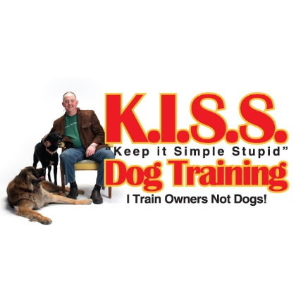
Date:
Dog’s Name:
Dog’s Age:
Dog’s Breed:
How long have you had the dog?

- What are the top three things you want to change in your dog?
- What type of things have you tried to fix the problem so far?

- What are your greatest concerns about these problems?
- Are these new issues? If not, how long have they been going on?
- What kinds of exercise does your dog get? How often?
- How much exposure does your dog get to the world outside your home? (field trips, dog parks, the car, daycare, the park, restaurants, coffee shops, etc.….)

- How do you feed your dog now?
- How does your dog do around people and/or other dogs?

- Does the behavior above change when on leash?

- Has the dog ever nipped or bit another person or dog? If so, specifically describe the incident and severity of the nip or bite… I need to know about all people, dog and other animal issues.

- Has your dog ever done damage that necessitated a visit to a doctor or a vet?

- Does your dog growl at people or other dogs?

- If a shelter/rescue pet, what do you know about the dog's past, including the name of the shelter/rescue (be as detailed as you can)

- Would you describe your dog as nervous, anxious or fearful?

- When was the last time your dog saw his or her vet, and are they part of this training processes? (They should be.)

- When your dog does something wrong how do you go about correcting it?
- Do you have a crate/kennel?

- Do you use it?

- If not, are you willing to use a crate/kennel in training if it will help to resolve your issues?

Also, keep in mind that before training can start you must not only read but also print out and sign (or email confirmation that you have) the Fine Print and FAQ on our website. You can find these under the “READ FIRST” tab at the top of the website….

